Nama : Daffa Fairuz Muslim  
NIM : 2231740027  
No Absen/Kelas : 09/1A

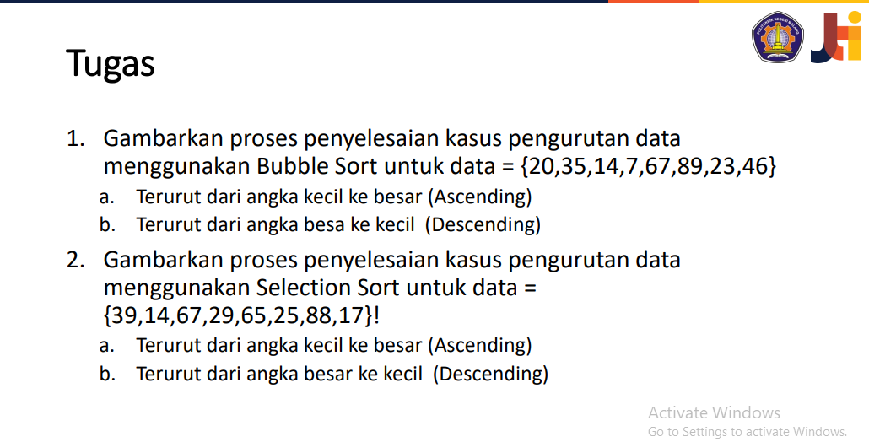

1. A. Ascending

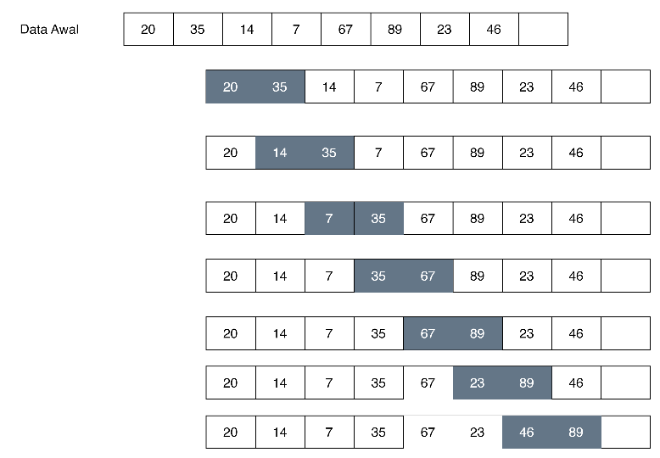

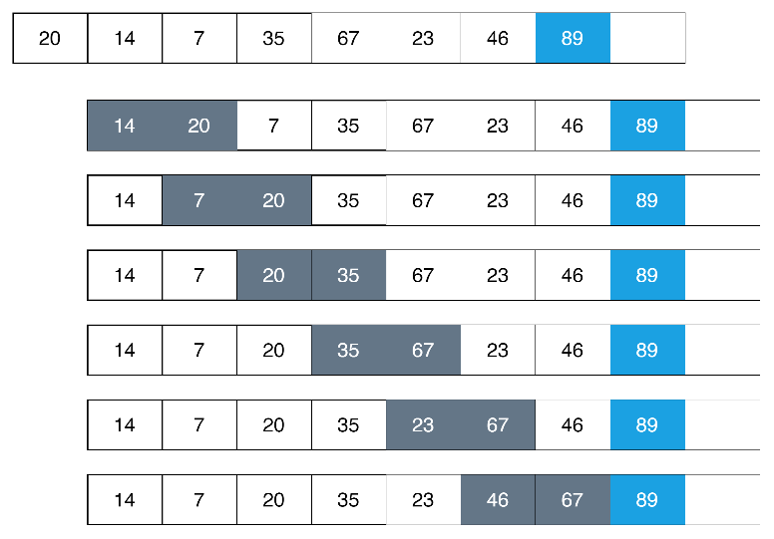

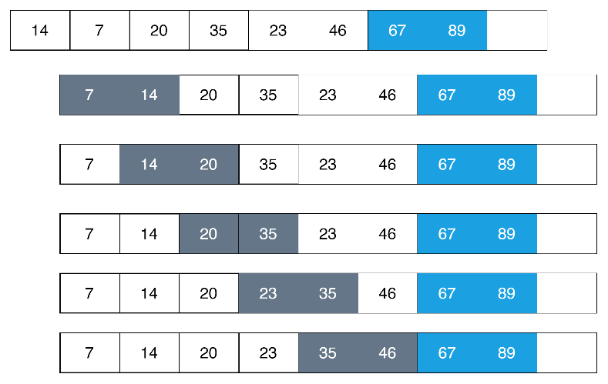

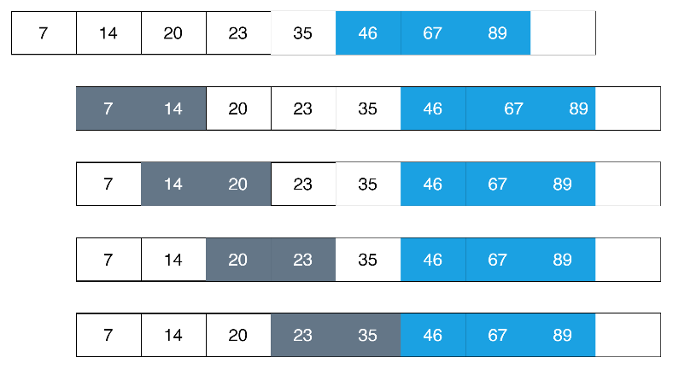

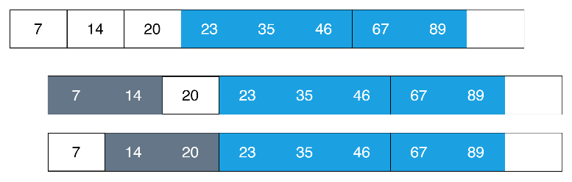

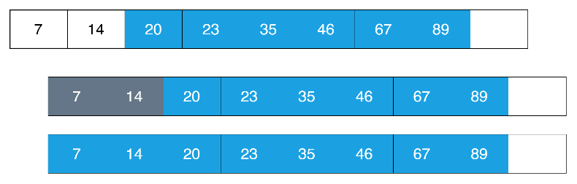

b. Descending

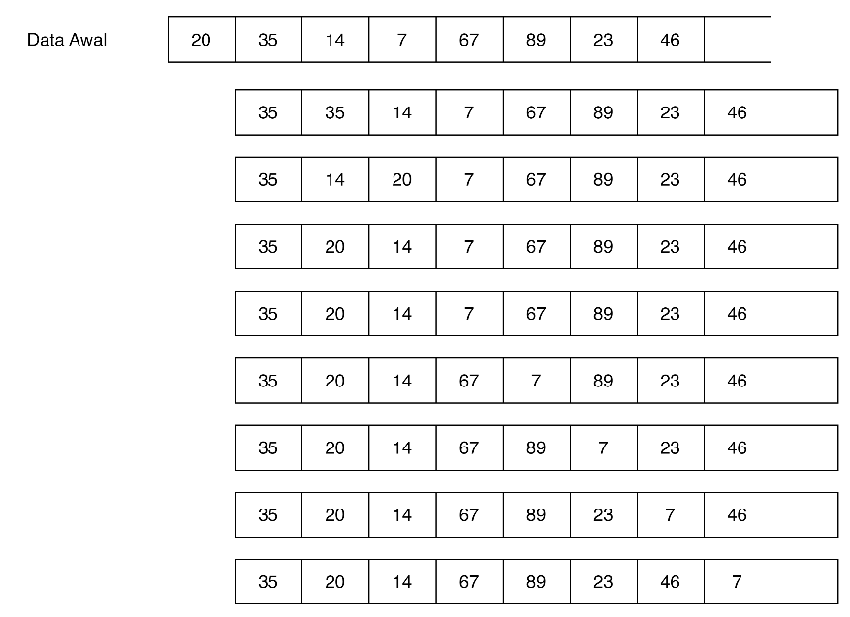

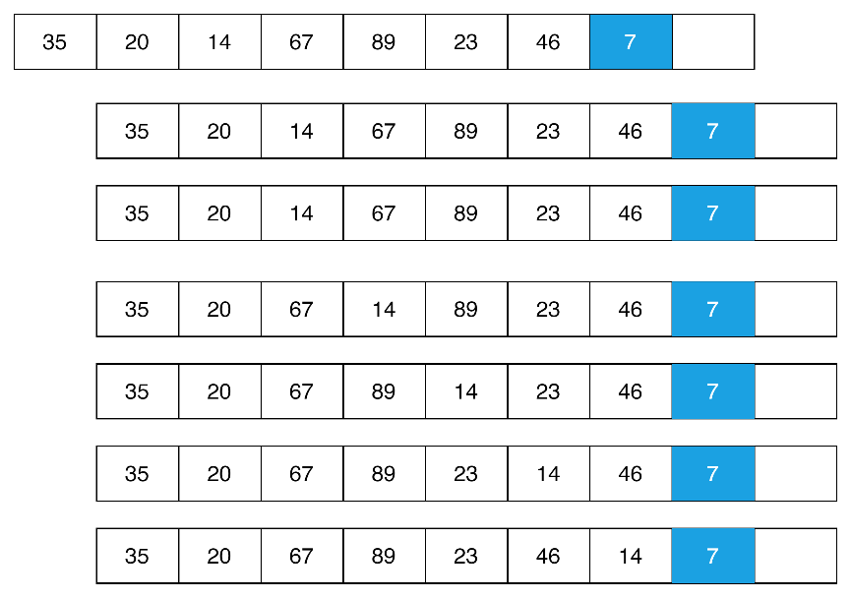

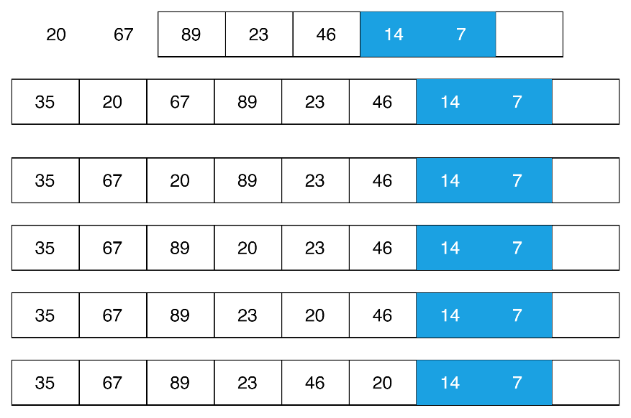

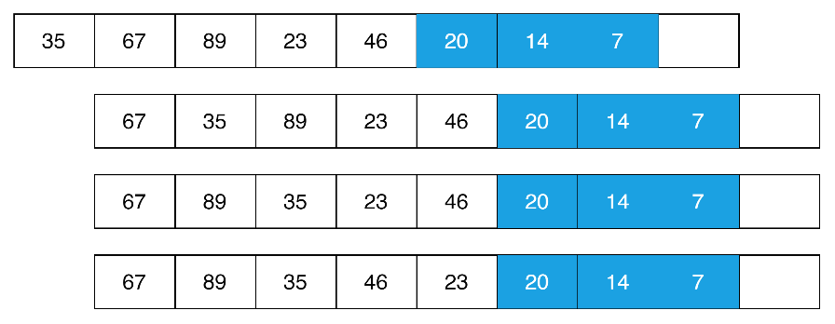

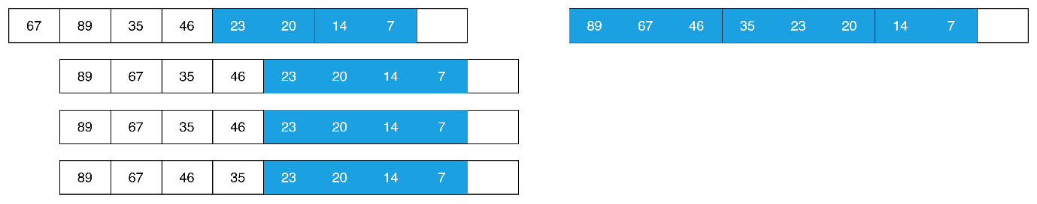

1. Data {39,14,67,29,65,25,25,88,17}
2. Ascending

|  |  |  |  |  |  |  |  |
| --- | --- | --- | --- | --- | --- | --- | --- |
| 39 | 14 | 67 | 29 | 65 | 25 | 88 | 17 |

|  |  |  |  |  |  |  |  |
| --- | --- | --- | --- | --- | --- | --- | --- |
| 14 | 39 | 67 | 29 | 65 | 25 | 88 | 17 |

|  |  |  |  |  |  |  |  |
| --- | --- | --- | --- | --- | --- | --- | --- |
| 14 | 17 | 67 | 29 | 65 | 25 | 88 | 39 |

|  |  |  |  |  |  |  |  |
| --- | --- | --- | --- | --- | --- | --- | --- |
| 14 | 17 | 25 | 29 | 65 | 67 | 88 | 39 |

|  |  |  |  |  |  |  |  |
| --- | --- | --- | --- | --- | --- | --- | --- |
| 14 | 17 | 25 | 29 | 39 | 67 | 88 | 65 |

|  |  |  |  |  |  |  |  |
| --- | --- | --- | --- | --- | --- | --- | --- |
| 14 | 17 | 25 | 29 | 39 | 65 | 88 | 67 |

|  |  |  |  |  |  |  |  |
| --- | --- | --- | --- | --- | --- | --- | --- |
| 14 | 17 | 25 | 29 | 39 | 65 | 67 | 88 |

1. Descending

|  |  |  |  |  |  |  |  |
| --- | --- | --- | --- | --- | --- | --- | --- |
| 39 | 14 | 67 | 29 | 65 | 25 | 88 | 17 |

|  |  |  |  |  |  |  |  |
| --- | --- | --- | --- | --- | --- | --- | --- |
| 88 | 14 | 67 | 29 | 65 | 25 | 39 | 17 |

|  |  |  |  |  |  |  |  |
| --- | --- | --- | --- | --- | --- | --- | --- |
| 88 | 67 | 14 | 29 | 65 | 25 | 39 | 17 |

|  |  |  |  |  |  |  |  |
| --- | --- | --- | --- | --- | --- | --- | --- |
| 88 | 67 | 14 | 29 | 65 | 25 | 39 | 17 |

|  |  |  |  |  |  |  |  |
| --- | --- | --- | --- | --- | --- | --- | --- |
| 88 | 67 | 65 | 29 | 14 | 25 | 39 | 17 |

|  |  |  |  |  |  |  |  |
| --- | --- | --- | --- | --- | --- | --- | --- |
| 88 | 67 | 65 | 39 | 14 | 25 | 29 | 17 |

|  |  |  |  |  |  |  |  |
| --- | --- | --- | --- | --- | --- | --- | --- |
| 88 | 67 | 65 | 39 | 29 | 25 | 14 | 17 |

|  |  |  |  |  |  |  |  |
| --- | --- | --- | --- | --- | --- | --- | --- |
| 88 | 67 | 65 | 39 | 29 | 25 | 14 | 17 |

|  |  |  |  |  |  |  |  |
| --- | --- | --- | --- | --- | --- | --- | --- |
| 88 | 67 | 65 | 39 | 29 | 25 | 17 | 14 |